**FEES MANAGEMENT SYSTEM**

**INTRODUCTION:**

College Fees Management System is a comprehensive software solution designed to revolutionize the way educational institutions manage student fees. The system aims to provide a user-friendly, efficient, and transparent platform for fee payments, tracking, and reporting. By automating manual processes, the system will reduce errors, increase productivity, and save time for administrators.

**ANALYSIS AND REQUIREMENT SPECIFICATION:**

**PURPOSE:**

The primary purposes of a fees management system are:

1. Efficient Fee Collection: reducing manual errors and ensuring timely payments.

2. Accurate Financial Records: Maintain accurate and up-to-date financial records, making it easier to track payments, outstanding fees, and financial trends.

3. Reduced Administrative Burden: Minimize the administrative workload associated with fee management, allowing staff to focus on other critical tasks.

4. Improved Communication: Enhance communication with students, parents, and staff regarding fee payments, deadlines, and notifications.

5. Secure and Reliable: Ensure the security and integrity of financial data, with features like access controls.

6. Reporting and Analytics: Generate detailed reports and analytics to inform financial decision-making and strategic planning.

**REQUIREMENTS:**

Netbeans ide:

NetBeans is an integrated development environment (IDE) for Java.

MySql:

MySQL is an open-source relational database management system. Its name is a combination of "My", the name of co-founder Michael Widenius's daughter My, and "SQL", the acronym for Structured Query Language

**DESIGN:**

**ER DIAGRAM:**

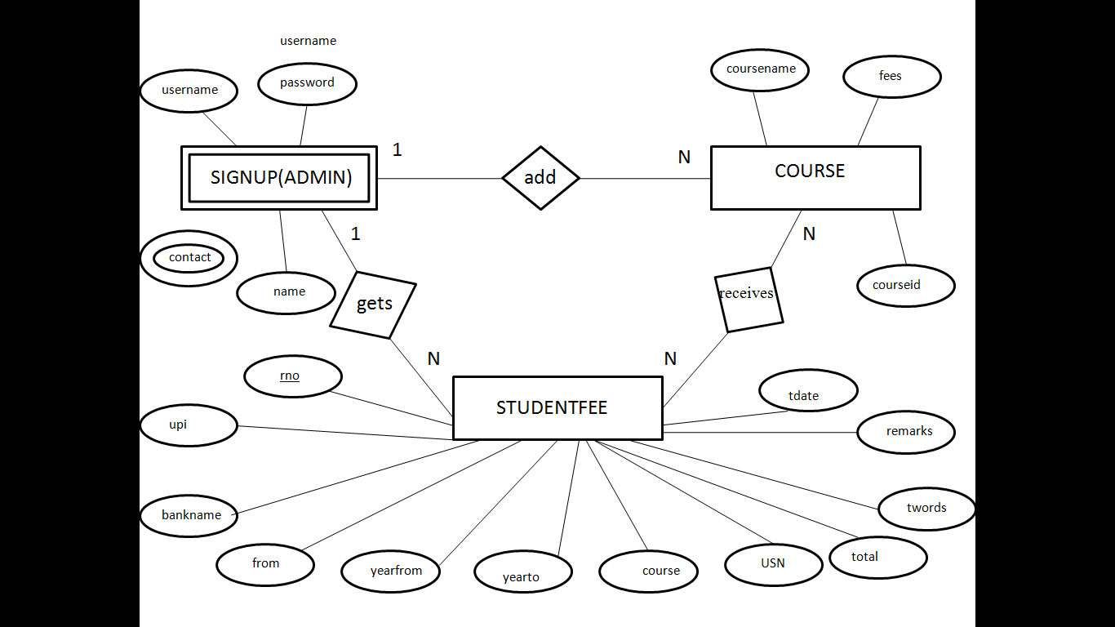

**SCHEMA:**

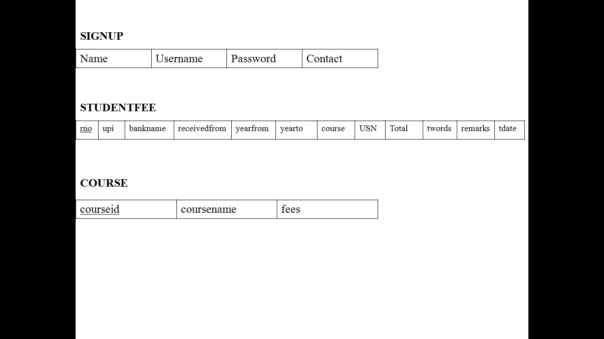

**FUTURE ENHANCEMENT:**

1. Artificial Intelligence (AI) Integration: Implement AI to predict student payment behavior, detect fraud, and offer personalized payment plans.

2. Mobile App: Develop a mobile app for students and parents to access fee statements, make payments, and receive notifications.

3. Blockchain Technology: Utilize blockchain for secure, transparent, and tamper-proof financial transactions.

4. Automated Scholarship Management: Integrate scholarship management, allowing for automated awarding and disbursement.

5. Real-time Payment Processing: Enable real-time payment processing, reducing payment clearance times.

6. Enhanced Reporting and Analytics: Expand reporting capabilities to include predictive analytics and data visualization.

7. Integration with Other Systems: Integrate with additional systems, such as accounting, ERP, or student information systems.

8. Online Payment Plans: Offer online payment plans, allowing students to schedule recurring payments.

9. Multi-Currency Support: Support multiple currencies for international students.

10. Security Enhancements: Continuously update security measures to protect sensitive financial information.

**CONCLUSION:**

The Fees Management System project has been successfully implemented to streamline student fee management, payments, and financial transactions. The system, built using NetBeans IDE and MySQL, ensures accuracy, efficiency, and reliability. It offers improved efficiency, transparency, and accountability, reducing manual errors and enhancing student satisfaction. The system is user-friendly, scalable, and secure, and can be easily integrated with existing systems. Future enhancements include integration with other systems, new features, and continuous testing. This project has successfully transformed the fee management process, and its impact will be valuable to any educational institution.